**BULID AN EVENT MANAGEMENT SYSTEM**

**USING SALESFORCE**

**Build an Event Management System using Salesforce**

This Project helps in managing the on-going and upcoming events in an organization.

**Project Description**

The project aim is to provide real-time knowledge for all the students who have basic knowledge of Salesforce and Looking for a real-time project.

What you'll learn

1. Real Time Salesforce Project

2. Object & Relationship in Salesforce

3. Create Salesforce Org:

**Introduction**

Event management is the process of creating and maintaining an event. This process spans from the very beginning of planning all the way to post-event strategizing.

At the start, an event manager makes planning decisions, such as the time, location, and theme of their event. During an event, event managers oversee the event live and make sure things run smoothly.

After an event, event managers are tasked with reviewing event data, submitting KPI and ROI findings, and staying on the ball for any post-event offerings.

**Milestone 1 - Salesforce?**

Salesforce is your customer success platform, designed to help you sell, service, market, analyze, and connect with your customers.

Salesforce has everything you need to run your business from anywhere.

Using standard products and features, you can manage relationships with prospects and customers, collaborate and engage with employees and partners, and store your data securely in the cloud.

**There are 5 types of salesforce editions:**

1. Essentials: Designed for small businesses getting started with CRM to boost sales or service productivity. It includes a setup assistant and administration tools to customize your deployment as you grow.

2. Professional: Designed for businesses requiring full-featured CRM functionality. It includes straightforward and easy-to-use customization, integration, and administration tools to facilitate any small to midsize deployment.

3. Enterprise: Meets the needs of large and complex businesses. It gives you advanced customization and administration tools, in addition to all the functionality available in Professional Edition, that can support large-scale deployments. Enterprise Edition also includes access to Salesforce APIs, so you can easily integrate with back-office systems.

4. Unlimited: Maximizes your success and extends it across the entire enterprise through the Lightning Platform. It gives you new levels of platform flexibility for managing and sharing all your information on demand. Includes all Enterprise Edition functionality, Premier Support, full mobile access, unlimited custom apps, increased storage limits, and other features.

5. Developer: Provides access to the Lightning Platform and APIs. It lets developers extend Salesforce, integrate with other applications, and develop new tools and applications. Developer Edition also provides access to many of the features available in Enterprise Edition.

**Activity:**

**Creating a Salesforce Developer Org:**

A Developer org has all the features and licenses you need to get started with Salesforce.

1. Search Developer.salesforce.com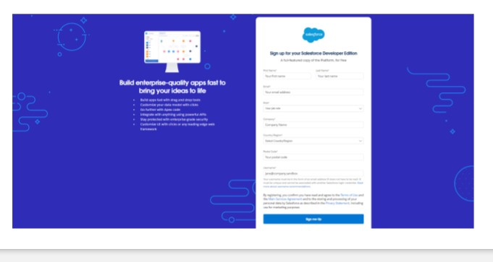
2. Enter the following details like First name, last name, Email, Role, Company, Country/Region, Postal code, and Username must be unique.
3. Click sign me up, after a few min you will reserve a mail salesforce org and by using the verify account link you can create your new password.

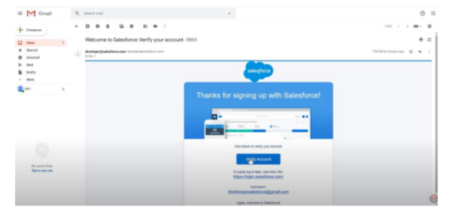

1. Click save.
2. Search login.salesforce.com

6. By using username and password you can into the salesforce org.

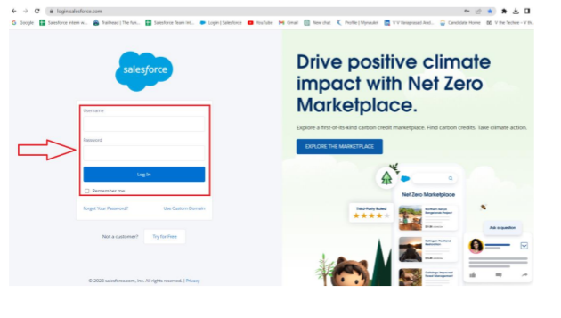

**The set up page will be appear as below.**

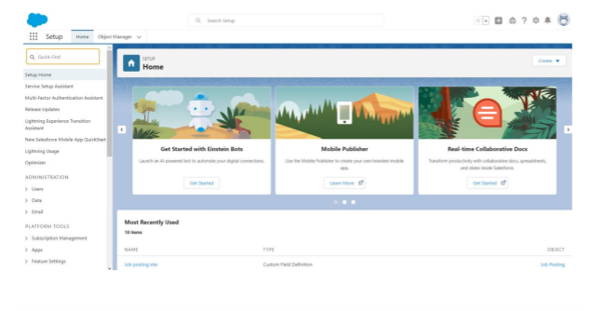

**Milestone 2 – Object:**

**What is an object?**

Salesforce objects are database tables that permit you to store data that is specific to an organization. It consists of fields (columns) and records (rows).

Salesforce objects are of two types:

• Standard Objects: Standard objects are the kind of objects that are provided by salesforce.com such as users, contracts, reports, dashboards, etc.

• Custom Objects: Custom objects are those objects that are created by users. They supply information that is unique and essential to their organization. They are the heart of any application and provide a structure for sharing data.

**Activity: 1**

**Creation of Objects for Event Management:**

For this Event management we need to create 4 objects i.e Events, Attendees, Speakers and vendors. The below steps will assist you in creating those objects.

1. Click on the gear icon and then select Setup.

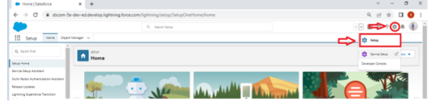

1. Click on the object manager tab just beside the home tab.

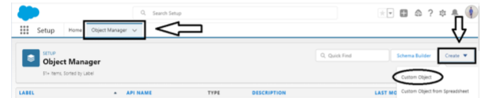

3. After the above steps, have a look on the extreme right you will find a Create Dropdownclick on that and select Custom Object.

● On the Custom Object Definition page, create the object as follows:

● Label: Event

● Plural Label: Events

● Record Name: Event Name

● Check the Allow Reports checkbox

● Check the Allow Search checkbox

● Click Save.

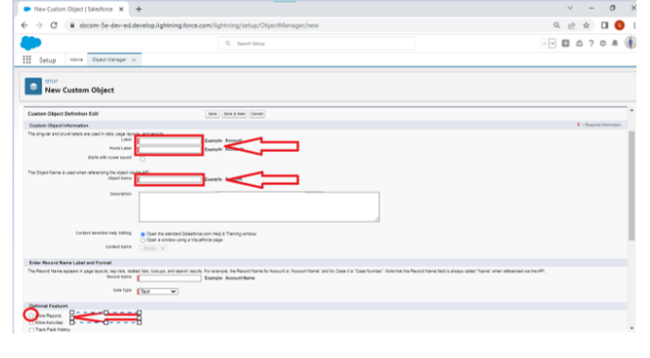

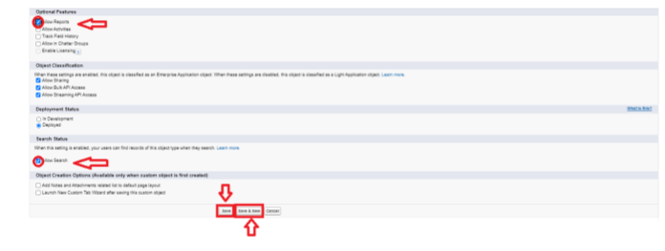

**Activity 2:**

**Creation of Attendees object:**

1. Click on the gear icon and then select Setup.

2. Click on the object manager tab just beside the home tab.

3. After the above steps, have a look on the extreme right you will find a Create Dropdownclick on that and select Custom Object.

a. On the Custom Object Definition page, create the object as follows:

b. Label: Attendee

c. Plural Label: Attendees

d. Record Name: Attendee Name

e. Check the Allow Reports checkbox

f. Check the Allow Search checkbox

g. Click Save.

**Activity 3:**

**Creation of Speaker object:**

1. Click on the gear icon and then select Setup.

2. Click on the object manager tab just beside the home tab.

3. After the above steps, have a look on the extreme right you will find a Create Dropdownclick on that and select Custom Object.

a. On the Custom Object Definition page, create the object as follows:

b. Label: Speaker

c. Plural Label: Speakers

d. Record Name: Speaker Name

e. Check the Allow Reports checkbox

f. Check the Allow Search checkbox

g. Click Save.

**Activity 4:**

**Creation of Vendors object:**

1. Click on the gear icon and then select Setup.

2. Click on the object manager tab just beside the home tab.

3. After the above steps, have a look on the extreme right you will find a Create Dropdownclick on that and select Custom Object.

a. On the Custom Object Definition page, create the object as follows:

b. Label: Vendor

c. Plural Label: Vendors

d. Record Name: Vendor Name

e. Check the Allow Reports checkbox

f. Check the Allow Search checkbox

g. Click Save.

**Milestone 3 –Tab:**

**Tab**

Tabs in Salesforce help users view the information at a glance. It displays the data of objects and other web content in the application.

There are mainly 4 types of tabs:

**Standard Object Tabs:**

Standard object tabs display data related to standard objects.

**Custom Object Tabs:**

Custom object tabs display data related to custom objects. These tabs look and function just like standard tabs.

**Web Tabs:**

Web Tabs display any external Web-based application or Web page in a Salesforce tab.

**Visualforce Tabs:**

Visualforce Tabs display data from a Visualforce Page.

NOTE: we wont be dealing with web tabs and visualforce tabs later.

**Activity 1:**

**Creation of Event tab:**

Now create a custom tab.

1. Click on Home tab, enter Tabs in Quick Find and select Tabs.

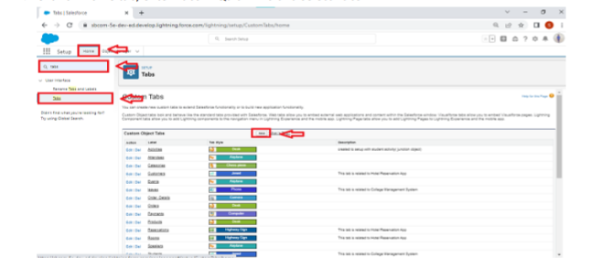

1. Under custom object tabs, New

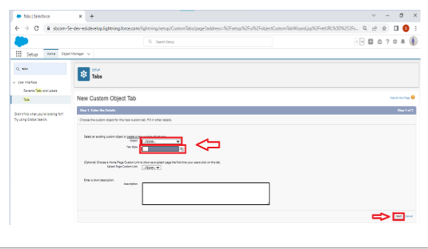

1. For Object, select Event.

1. For Tab Style, select any icon.
2. Leave all defaults as is. Click Next, Next, and Save.

**Activity 2:**

**Creation of Attendee tab:**

Now create a custom tab.

1. Click on Home tab, enter Tabs in Quick Find and select Tabs.

2. Under custom object tabs, click New.

3. For Object, select Attendee.

4. For Tab Style, select any icon.

5. Leave all defaults as is. Click Next, Next, and Save.

**Activity : 3**

**Creation of Speakers tab:**

Now create a custom tab.

1. Click on Home tab, enter Tabs in Quick Find and select Tabs.

2. Under custom object tabs, click New.

3. For Object, select Speaker.

4. For Tab Style, select any icon.

5. Leave all defaults as is. Click Next, Next, and Save.

**Activity 4:**

**Creation of Vendor tab:**

Now create a custom tab.

1. Click on Home tab, enter Tabs in Quick Find and select Tabs.

2. Under custom object tabs, click New.

3. For Object, select Vendor.

4. For Tab Style, select any icon.

5. Leave all defaults as is. Click Next, Next, and Save.

**Milestone 3 – Application:**

What is an App?

Apps in Salesforce are a group of tabs that help the application function by working together as a unit. It has a name, a logo, and a particular set of tabs. The simplest app usually has just two tabs.

There are 2 types of Salesforce applications:

• Standard apps: these apps come with every occurrence of Salesforce as default. Community, Call Center, Content, Sales, Marketing, Salesforce Chatter, Site.com, and App Launcher are included in these apps. The description, logo, and label of a standard app cannot be altered.

• Custom apps: these apps are created according to the needs of a company. They can be made by putting custom and standard tabs together. Logos for custom apps can be changed.

**Activity**

**Create the Event Management Construction app**

● From Setup, enter App Manager in the Quick Find and select App Manager.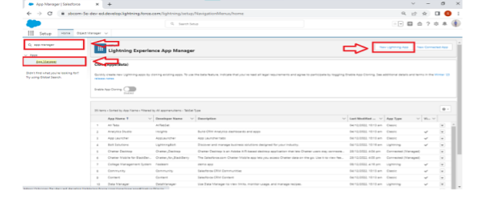

● Click New Lightning App. Enter Event Management as the App Name, then click Next

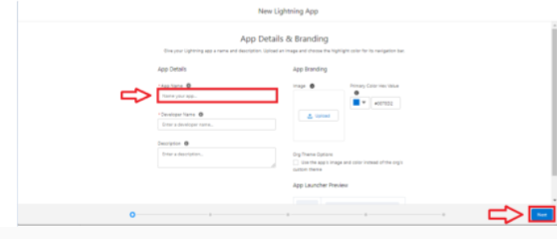

● Under App Options, leave the default selections and click Next.

● Under Utility Items, leave as is and click Next.

● From Available Items, select Events, Attendees, speakers, vendors, Reports, andDashboards and move them to Selected Items. Click Next.

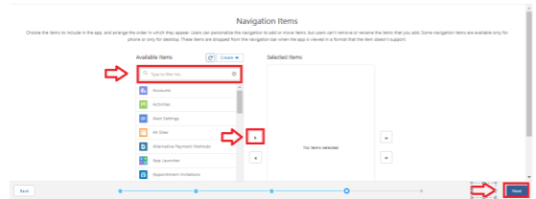

● From Available Profiles, select System Administrator and move it to Selected Profiles. Click Save & Finish.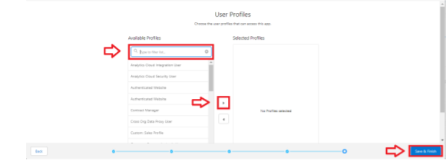

● To verify your changes, click the App Launcher, type School Management and select the School Management app.

Note:

1. App Launcher-Displays available apps.

2. App Name-Displays the current selected app.

3. Navigation menu-Displays the tabs available inside the app.

**Milestone 4 – Fields:**

**What are fields?**

Fields in Salesforce represents what the columns represent in relational databases. It can store data values which are required for a particular object in a record.

There are 2 types of fields in salesforce:

• Standard fields: There are four standard fields in every custom object that are Created By, Last Modified By, Owner, and the field created at the time of the creation of an object. These fields cannot be deleted or edited and they are always required. For standard objects, the fields which are present by default in them and cannot be deleted from standard objects are standard fields.

• Custom fields: The Custom fields which are added by the administrator/developer to meet the business requirements of any organization. They may or may not be required.

**Activity 1:**

**Creation of fields for the Event objects:**

1. click the gear icon and select Setup. This launches Setup in a new tab.

2. Click the Object Manager tab next to Home.

3. Select Event.

4. Select Fields & Relationships from the left navigation, and click New

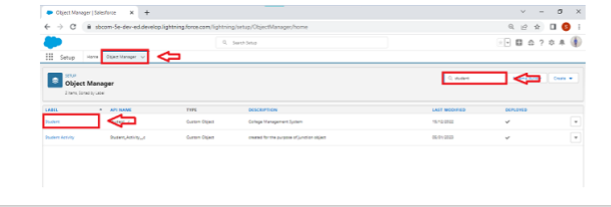

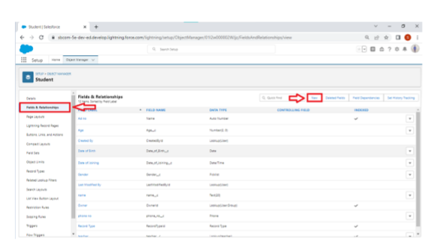

Now we're ready to make a custom field. Let's do this!

5. Select the Text as the Data Type, then click Next.

6. For Field Label, enter City.

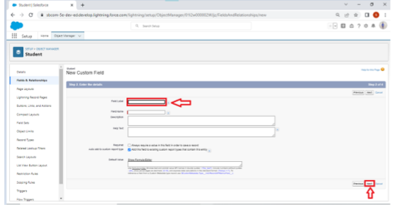

1. Click Next, Next, then Save & New.

Now let's create the other fields and we must choose the data types of the fields carefully .Let's have a look at it.

For example, a phone number is a number field. For that we need to select the phone as datatype.

Lets see this

1. Select the Date/time as the Data Type, then click Next.

2. For Field Label, enter Start Date.

3. Check the required check box.

4. Click Next, Next, then Save & New.

5. Similarly create a End Date field also

**Activity 2:**

**Creation of fields for the Attendees objects:**

1. Select the Auto number as the Data Type, then click Next.

2. For Field Label, enter Id.

3. Click Next, Next, then Save & New

4. Select the phone as the Data Type, then click Next.

5. For Field Label, Phone.

6. Click Next, Next, then Save & New.

7. Select the Email as the Data Type, then click Next.

8. For Field Label, enter Email.

9. Click Next, Next, then Save & New.

10. From Setup, click Object Manager and select Student.

11. Click Fields & Relationships, then New.

12. Select Picklist as the Data Type and click Next.

13. For Field Label enter Tickets.

14. Select Enter values, with each value separated by a new line and enter these values:

● Premium

● Gold

● Silver

15. Click Next, Next, then Save & New

**Activity 3:**

**Let's create a master-detail relationship with Event object**

1. Select master-detail Relationship as the Data Type and click Next.

2. For Related to, enter Event.

3. Click Next.

4. For Field Label, Event Name.

5. Click Next, Next, Next and Save.

**Activity 4:**

**Creation of fields for the Speakers objects:**

1. Select the Text Area as the Data Type, then click Next.

2. For Field Label, enter Bio.

3. Click Next, Next, then Save & New.

4. Select the Email as the Data Type, then click Next.

5. For Field Label, e-mail.

6. Click Next, Next, then Save & New

Let's create a Look-up relationship with Event object

1. Select Look-up Relationship as the Data Type and click Next.

2. For Related to, enter Event.

3. Click Next.

4. For Field Label, Event Name.

5. Click Next, Next, Next and Save.

**Activity 5:**

**Creation of fields for the Vendors objects:**

1. Select the Email as the Data Type, then click Next.

2. For Field Label, e-mail.

3. Click Next, Next, then Save & New.

4. Select the phone as the Data Type, then click Next.

5. For Field Label, Phone.

6. Click Next, Next, then Save & New.

7. Select the Email as the Data Type, then click Next.

8. For Field Label, e-mail.

9. Click Next, Next, then Save & New

10. Select the Text as the Data Type, then click Next.

11. For Field Label, enter Service Provider.

12. Click Next, Next, then Save & New.

13. Select Look-up Relationship as the Data Type and click Next.

14. For Related to, enter Event.

15. Click Next.

16. For Field Label, Event Name.

17. Click Next, Next, Next and Save.

**Milestone 5 – Profile:**

What is a profile?

A profile is a group/collection of settings and permissions that define what a user can do in salesforce. A profile controls “Object permissions, Field permissions, User permissions, Tab settings, App settings, Apex class access, Visualforce page access, Page layouts, Record Types, Login hours & Login IP ranges.

A profile can be assigned to many users, but user can be assigned single profile at a time.

**Activity 1:**

**Creation on profile:**

1. From Setup enter Profiles in the Quick Find box, and select Profiles.

2. From the list of profiles, find Standard User.

3. Click Clone.

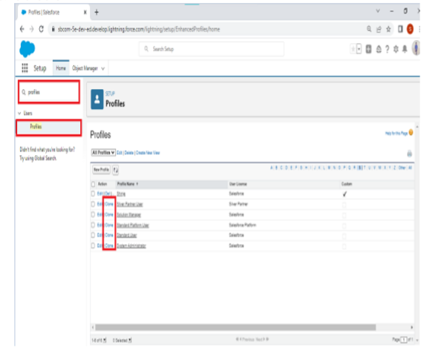

1. For Profile Name, enter Event user profile.
2. Click Save

